# **Udacity DVD Rental Project 1**

**Project Submissions**

**Presentations**

**You are now on the portion of the project you will need to submit to a reviewer. To pass this project follow the instructions below to create a presentation. You will submit a zip file with two items:**

* **Slide Deck (4 slides)**
* **Text File with SQL queries**

**Your presentation should include:**

* **Four slides**
* **One question on each slide**
* **One visualization (graph / chart / table) per slide**
* **A 1-2 sentence answer to the question, based on the data and visualization, on each slide**
* **Indicate which code in the attached text file was used to create the visualization OR add the query used to generate the visualization.**

**Note: You may choose to use queries that were motivated by the two Question Sets, or you may choose four entirely new questions. However, you cannot use questions or queries resembling any of the ones in Practice Quiz #1 and #2. Make sure your queries meet the requirements specified in the**[**Rubric**](https://review.udacity.com/#!/rubrics/2095/view)**.**

**You may use any slideshow application you like, such as Google Slides, Powerpoint, or Keynote. We are providing you a template below (see blue button titled Submission Template) that you may use for your presentation, if you'd like. If you want to use PowerPoint or Keynote or some other application instead, just adapt this template for the application you choose. For your convenience, we have provided the PowerPoint slides in the Resources.**

**Make a copy of the submission template to complete your project. We suggest you use the layout provided, though it is not a requirement.**

**Queries**

**Please create a text file, using an application such as Notepad, Notepad++, or any other text editor - at Udacity we are fond of Atom. This file should include each of the queries you used to create your visualizations.**

**An important aspect of writing SQL queries is following a recommended format. This will improve readability and troubleshooting when you encounter an exception or error. Two such highly recommended SQL guides are the following two:**

* [**https://www.sqlstyle.guide/**](https://www.sqlstyle.guide/)
* [**http://www.sql-format.com/**](http://www.sql-format.com/)

**We encourage you to use the SQL Style Guide to help you write well formatted SQL queries and improve their readability.**

**[[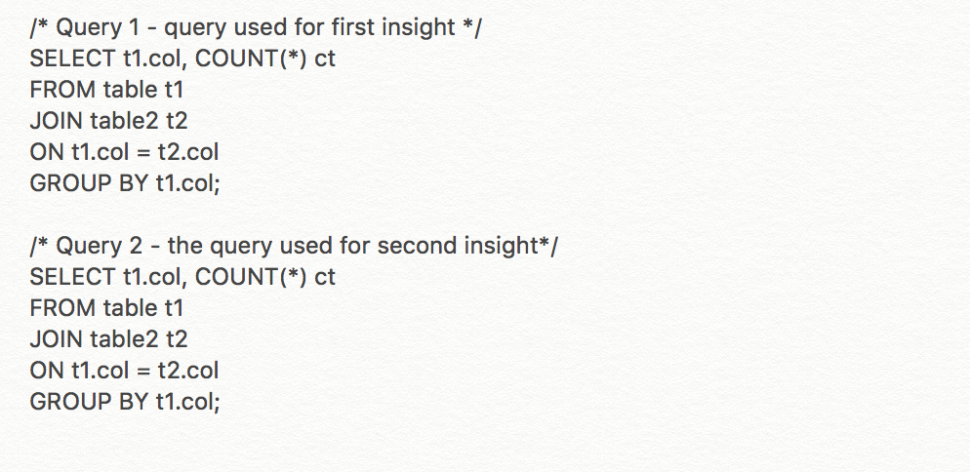](https://classroom.udacity.com/nanodegrees/nd104-ent/parts/8b91557b-bc8a-4b87-a1f3-bd5b6d921d4e/modules/88381523-c67f-4d93-baae-9d3c93dc0db0/lessons/3dc22711-adb9-4e58-a299-fc89bce79d86/concepts/eebd783f-5a4d-45a8-9f8d-25ab6ea93946)](https://classroom.udacity.com/nanodegrees/nd104-ent/parts/8b91557b-bc8a-4b87-a1f3-bd5b6d921d4e/modules/88381523-c67f-4d93-baae-9d3c93dc0db0/lessons/3dc22711-adb9-4e58-a299-fc89bce79d86/concepts/eebd783f-5a4d-45a8-9f8d-25ab6ea93946)**

**[Sample Text File](https://classroom.udacity.com/nanodegrees/nd104-ent/parts/8b91557b-bc8a-4b87-a1f3-bd5b6d921d4e/modules/88381523-c67f-4d93-baae-9d3c93dc0db0/lessons/3dc22711-adb9-4e58-a299-fc89bce79d86/concepts/eebd783f-5a4d-45a8-9f8d-25ab6ea93946)**

**Put your text file and presentation in a folder and zip it. Then submit the zipped folder for your project. A slide template is provided here:**

[**SUBMISSION TEMPLATE**](https://docs.google.com/presentation/d/1l6NMD_m4J4Mfb2wd4WP_x2hwCkCZ5-isWhGan2SIURg/edit?usp=sharing)

**Visualizations**

**We suggest you use a spreadsheet application, such as Excel or Google Sheets to create your visualizations. However, you’re welcome to use whatever tool you’d like. Below is one example, and a link has been provided to an example slide.**

**[[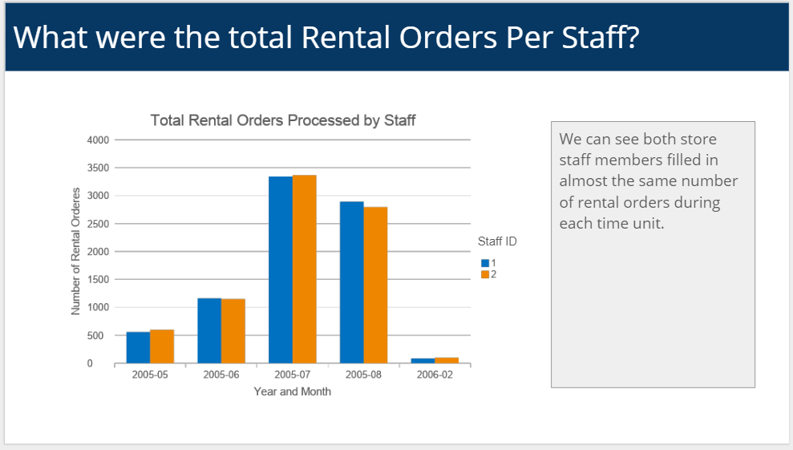](https://classroom.udacity.com/nanodegrees/nd104-ent/parts/8b91557b-bc8a-4b87-a1f3-bd5b6d921d4e/modules/88381523-c67f-4d93-baae-9d3c93dc0db0/lessons/3dc22711-adb9-4e58-a299-fc89bce79d86/concepts/eebd783f-5a4d-45a8-9f8d-25ab6ea93946)](https://classroom.udacity.com/nanodegrees/nd104-ent/parts/8b91557b-bc8a-4b87-a1f3-bd5b6d921d4e/modules/88381523-c67f-4d93-baae-9d3c93dc0db0/lessons/3dc22711-adb9-4e58-a299-fc89bce79d86/concepts/eebd783f-5a4d-45a8-9f8d-25ab6ea93946)**

**You should have four slides that are similar to the Submission Slide Example below. Remember:**

* **The questions you ask are up to you.**
* **All four of your final submitted queries should contain a JOIN and AGGREGATION.**
* **At least two of your final submitted queries should contain either a subquery OR a CTE.**
* **At least one of your final submitted queries should contain a Window Function.**
* **At least one column generated by the Window Function should be included in one of your final visualization.**

[**SUBMISSION SLIDE EXAMPLE**](https://docs.google.com/presentation/d/12SaYwkKvl4t54vx0voMxphvIuXUXE0XMTRtwRggaiyw/edit?usp=sharing)

**How to Get Data Into Excel**

**In order to create the visualizations, you will need to move your data out of workspace and into Excel (or another spreadsheet application). To export the results of your queries from the Project Workspace, use the Download CSV button (see image below) which is on the top right of the results window.**

**[[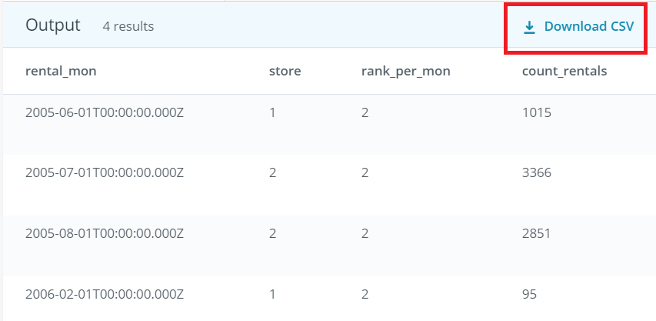](https://classroom.udacity.com/nanodegrees/nd104-ent/parts/8b91557b-bc8a-4b87-a1f3-bd5b6d921d4e/modules/88381523-c67f-4d93-baae-9d3c93dc0db0/lessons/3dc22711-adb9-4e58-a299-fc89bce79d86/concepts/eebd783f-5a4d-45a8-9f8d-25ab6ea93946)](https://classroom.udacity.com/nanodegrees/nd104-ent/parts/8b91557b-bc8a-4b87-a1f3-bd5b6d921d4e/modules/88381523-c67f-4d93-baae-9d3c93dc0db0/lessons/3dc22711-adb9-4e58-a299-fc89bce79d86/concepts/eebd783f-5a4d-45a8-9f8d-25ab6ea93946)**

**Additional Guidelines:**

* **There shouldn’t be any additional data prep (sorting, filtering, renaming, etc.) between the query output and the visualization.**
* **Review your project against the**[**project rubric**](https://review.udacity.com/#!/rubrics/2095/view)**.**
* **Reviewers will use this to evaluate your work.**
* **The first part of this project is aimed at helping you understand the database, so you can ask interesting questions in the second part. Feel free to use and expand upon the queries you wrote in the first part.**
* **Once you've finished your project, submit the presentation as a PDF and the queries as a .txt file.**

**In order to review your presentation, you will need to save your slides as a PDF. You can do this from within Google Slides by selecting File > Download as > PDF Document.**

**Supporting Materials**

[**SQL Project Submission Template**](https://video.udacity-data.com/topher/2018/May/5b0de21b_sql-project-submission-template-1/sql-project-submission-template-1.pptx)

### **Aggregations**

Be careful with Aggregations! You need to include all of the columns you are returning other than the aggregation in your group by statement.

Correct:

**SELECT** film_id, **count**(*)

**FROM** inventory

**GROUP** **BY** film_id

* This returns 958 rows, with the film_id and the number of inventory associated with that film_id.

Incorrect:

**SELECT** **count**(film_id)

**FROM** inventory

* This returns 1 row, with the count of film_id in the table.

If a column in the select statement is not in the Group By statement your results will be something you are not expecting. Please be careful of this!

### **Subqueries**

Subqueries are awesome but you should not use one if you do not need it to answer the question you asked. Many times the first question that is thought of does not require one. You may need to think of a few more to find a complex question that necessitates a subquery.

**Think of using a subquery when a SQL query is nested within another query. You need it to further restrict the returned data, so give careful thought to where.**

### Window Functions

Window Functions are extremely **useful for creating an aggregation or doing any other calculation across a subset of rows.** Once you have completed the calculation across the subset of rows, you can then reference the calculation as a new column in the query. You are required to use a window function in your query for this project.

Think about when you need to aggregate across a subset of rows within a larger data table resulting from a query.

### **Joins**

Joins in general should be from a Primary Key to its corresponding Foreign Key.

Correct: ON inventory.inventory_id = rental.inventory_id

* Here, Inventory PrimaryKey = Inventory ForeignKey

Incorrect: ON inventory.inventory_id = rental.rental_id

* Here, Inventory PrimaryKey does not equal Rental PrimaryKey

### Understanding the data

The Rentals table captures the rental history of the inventory of movie titles. Keep this in mind in case you are trying to show which movie has the most rentals. You would have to show which movie has the most copies or inventory rented out.

**Helpful tips and strategies!**

Take the time to get familiar with each table in the ERD. Run basic queries to understand the tables and how they relate to each other. This is a critical foundational step to building advanced queries.

* Start creating and posing your questions, then work backwards to identify the tables you'll need to answer your questions.
* Pay attention to the intermediate query results you will need to take to get to the final query result.
* Break down the logic of the question to identify and draw out the table for each subquery and the final query result you are aiming for. These intermediate tables can also help you identify any subquery, common table expression or Window Function you may need to run.
* Take breaks! Abstract concepts need time to percolate through so you can see a solution. When you find yourself in a rut with a difficult problem, take a short break and then come back to try it again.